Welding Light Filtering

Screens or Curtains
Welding screens consist of semitransparent vinyl (PVC) mounted on portable frames, allowing for flexible reconfiguration or temporary enclosures. These are optimal for construction sites or mobile operations. Conversely, welding curtains are suspended from ceilings or stationary frames using grommets or overlapping PVC strips. Curtains are typically employed for permanent welding booths where the barrier remains stationary.

Safety Standards
Protective barriers must comply with regulatory bodies such as OSHA and ANSI. In the United States, the governing standard is AWS F2.3M:2019 (Specification for Use and Performance of Transparent Welding Curtains and Screens). This standard mandates specific optical protection levels against UV and blue light radiation, as well as strict flammability performance. To ensure compliance, manufacturers must validate products through independent laboratory testing and label them with the standard designation, manufacturer name, and date of production.

Colors
Color selection dictates the level of visible light transmission (VLT) and the ability to supervise the process. Screens are categorized into four grades: Light (L), Medium (M), Dark (D), and Extra Dark (ED).
- Yellow (Grade L): Offers maximum transparency, facilitating internal visibility and supervision. However, the high VLT makes these unsuitable for areas where bystanders are continuously exposed to arc light.
- Bronze or Green (Grade D): Minimizes VLT to maximize bystander comfort. These retain sufficient transparency to verify the welder's safety and presence but significantly reduce glare.
- Red (Grade M): A common compromise that balances effective supervision with reduced light transmission for bystander comfort.
- Matte Green/Shade 8 (Grade ED): Primarily used as partitions between welding booths. These block the majority of visible light to prevent distraction between neighboring welders where direct supervision is unnecessary.
- Blue: Blue material is unsuitable for welding applications. It fails to adequately filter blue light radiation and does not meet AWS F2.3 or ISO 25980 safety standards.

Option 1. Custom Built Welding Curtains (Not the best choice)
https://www.strip-curtains.com/proCat/WeldingCurtains.php
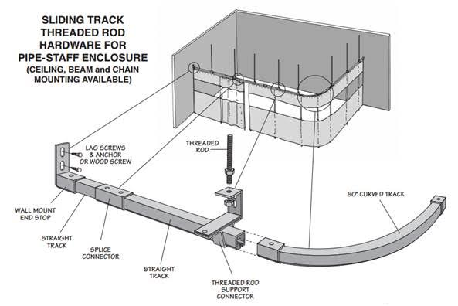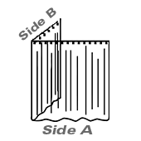

Config Details
SKU: WHDIV-L-SHAPE (2 SIDES)
Layout: L-Shape (2 sides)
Mounting Method: Threaded Rod Ceiling Mount
Side A: 11' 0" X 6' 0"
Color: 14 Mil Azted Red Weld Semi Transparent
Side B: 5' 0" X 6' 0"
Color: 14 Mil Azted Red Weld Semi Transparent

Included hardware:
16 Gauge Galvanized Steel Track - For Sliding Curtains and Doors - 6' length (Qty: 3)
Nylon Roller with 1/2" or 1" hook - 30 lb capacity (Qty: 16)
Straight Track Connector - Joins Two Sections of Track (Qty: 2)
16 Gauge Threaded Rod Connector - Allows Track to be suspended with 3/8 rod (Qty: 4)

Price: $ 309.50
Weight: 38.08 Lbs
Shipping: $ 47.58

Additional hardware (McMaster):
Line | Quantity | Unit of Measure | Product | Description | Unit Price | Total
1 | 1 | Pack of 10 each | 11715T72 | Ceiling Mount for 3/8"-16 Threaded Rod | 19.21 | 19.21
2 | 1 | Pack of 5 each | 97085A815 | Threaded Rod Anchor Ceiling Mount, for 3/8"-16 Thread, 1150 lbs. Capacity | 14.12 | 14.12
3 | 1 | Pack of 5 each | 95412A646 | 18-8 Stainless Steel Threaded Rod 3/8"-16 Thread Size, 6" Long | 18.78 | 18.78
4 | 1 | Pack of 25 each | 92673A125 | Corrosion-Resistant 18-8 Stainless Steel Hex Nut with Material Certificate, 3/8"-16 Thread Size, ASTM F594 | 2.55 | 2.55
5 | 1 | Pack of 100 each | 92141A031 | 18-8 Stainless Steel Washer for 3/8" Screw Size, General Purpose, 0.406" ID, 0.875" OD | 6.15 | 6.15
Merchandise $60.81

Option 2. VEVOR Welding Screen with Frame
6' x 6' 3 Panel Welding Curtain Screens, Flame-Resistant Vinyl Welding Protection Screen on 12 Swivel Wheels (6 Lockable)

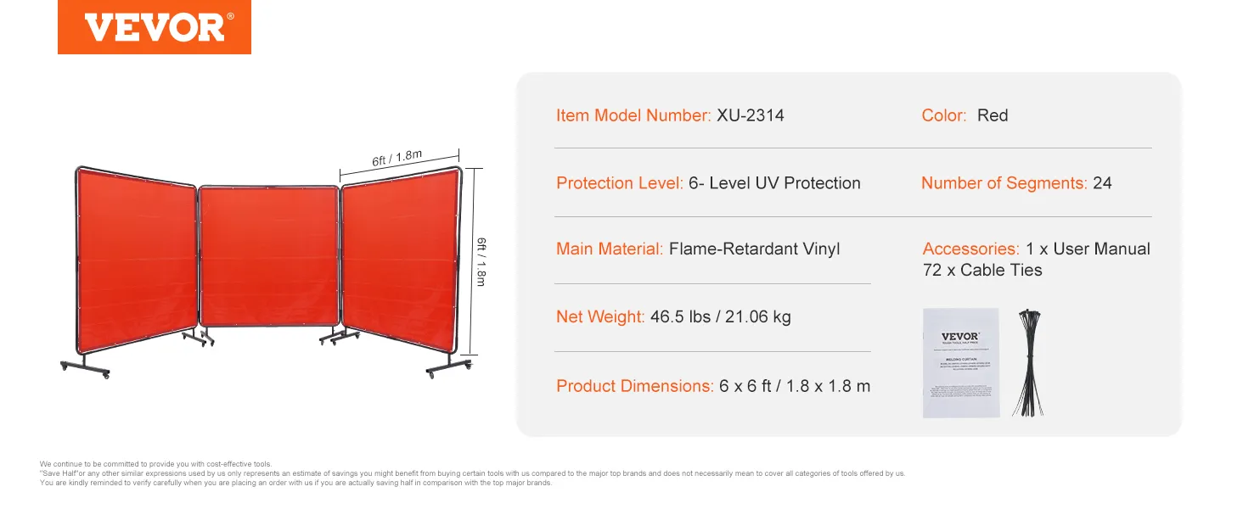
Minimal amount of assembling, no hardware required.
on LOWE'S site
on VEVOR site

130 USD / 3 Panels

Product specification
Item Model Number | XU-2314
Color | Red
Protection Level | 6- Level UV Protection
Main Material | Flame-Retardant Vinyl
Number of Segments | 24
Net Weight | 46.4 lbs / 21.06 kg
Single Screen Dimensions | 6 x 6 ft / 1.8 x 1.8 m

Welding EXHAUST Duct
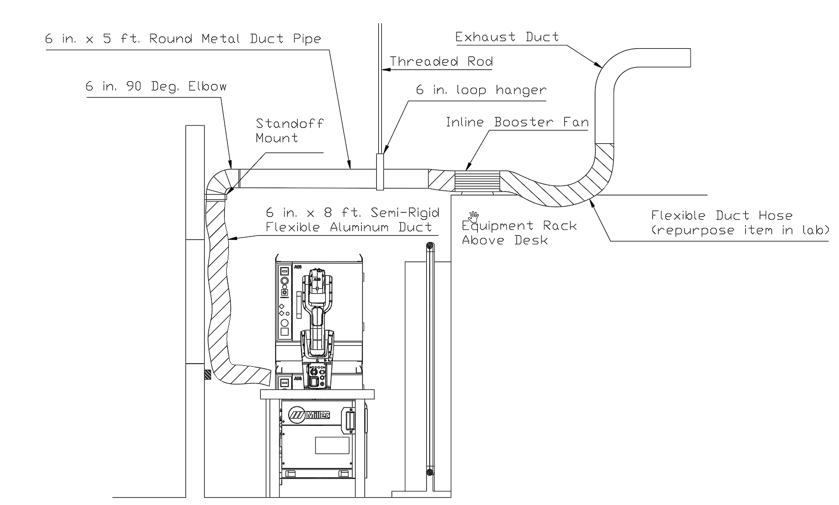

Bill of Materials
Line | Quantity | Product | Description | Unit Price | Total
1 | 1 | 327483763 | VIVOSUN 275 CFM 6 in. Inline Booster Duct Fan with Speed Controller | 34.99 | 34.99
2 | 0 | 334751996 | SKYSHALO Inline Duct Fan, 6 in. 400 CFM with Variable Speed Controller | 57.76 | 0
3 | 1 | 100125106 | 6 in. x 5 ft. Round Metal Duct Pipe, 30-Gauge Galvanized Steel | 16.98 | 16.98
4 | 1 | 203626515 | 6 in. x 8 ft. Semi-Rigid Flexible Aluminum Duct | 21.97 | 21.97
5 | 3 | 203626509 | 6 in. Galvanized Steel Worm Gear Clamp, 5-1/8 in. to 6-1/2 in. | 4.47 | 4.47
6 | 1 | 100396940 | 6 in. Flexible Duct and Sheet Metal Connector Splice Collar | 7.98 | 7.98
7 | 1 | 100062966 | 6 in. 90 Deg. Round Adjustable Elbow, 30-Gauge Galvanized Steel | 8.68 | 8.68
8 | 2 | 3064T22 | Swivel Threaded-Rod-Mount Loop Hanger, Zinc-Plated Steel, 6-5/8" ID | 9.40 | 9.40

inline Duct Fan

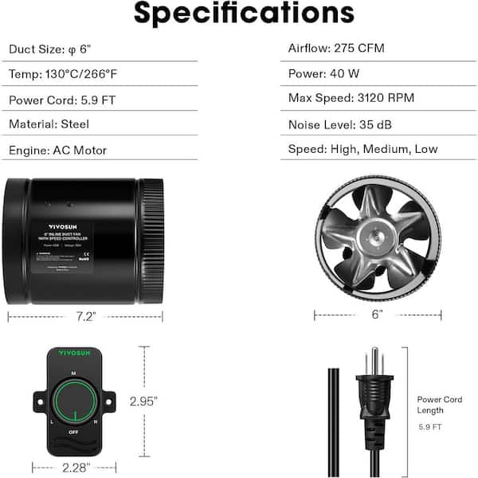
Option 1. VIVOSUN 275 CFM 6 in. Inline Booster Duct Fan with Speed Controller for HVAC Exhaust Ventilation
HomeDepot Link

34.99 USD

- 275 CFM airflow
- Durable steel housing
- Variable speed controller
- Less than 35 dB noise level

Product specification
Internet # 327483763
Model # WAL-VSV-IFB6
Dimensions
Product Depth (in.) | 7.2 in
Product Height (in.) | 6 in
Product Width (in.) | 6 in
Amperage (A) | 0.33 A
Brand/Model Compatibility | None
Duct Type | 6" Round
Horsepower (hp) | 0.05 hp
HVAC application | Ventilation
Material | Steel
Maximum air flow (CFM) | 275
Pack Size | 1
Product Weight (lb.) | 3.16 lb

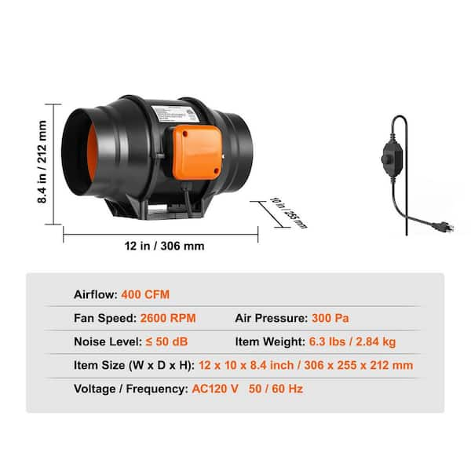
Option 2. SKYSHALO Inline Duct Fan, 6 in. 400 CFM with Variable Speed Controller, Quiet AC-Motor Ventilation Exhaust Fan for Booster
HomeDepot Link

57.76 USD

- Provides a sufficient airflow of 400 CFM
- Low noise of 34 dB
- Manual knobs to adjust fan speed
- Includes hang-up slings, non-vibration rubber mats and straps for installation

Product specification
Internet # 334751996
Model # XLGDFJYCHSAC6J5DVV1-250208
Dimensions
Product Depth (in.) | 12 in
Product Height (in.) | 8.4 in
Product Width (in.) | 10 in
Amperage (A) | 0.54 A
Duct Type | 6" Round
Horsepower (hp) | 0.08 hp
HVAC application | Ventilation
Material | Copper
Maximum air flow (CFM) | 400
Pack Size | 1
Product Weight (lb.) | 6.3 lb
Returnable | 90-Day
Voltage (volts) | 110

Welding Fume Extraction Duct

6 in. x 5 ft. Round Metal Duct Pipe
HomeDepot Link
16.98 USD
- 30-Gauge galvanized steel construction ensures long-term structural integrity
- Features a snap-lock design for efficient and secure assembly without specialized tools
- Crimped end facilitates a precise interlocking connection with adjacent ductwork components
- Engineered for high-efficiency airflow in main trunk lines, branch lines, and return air systems
- Material maintains flexibility for modification to specific lengths using standard tin snips
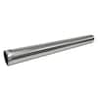
Product specification
Internet # 100125106
Model # CP6X60
Store SKU # 148679
Dimensions
Product Depth (in.) | 6.0 in
Product Diameter (in.) | 6.0 in
Product Height (in.) | 5.0 in
Product Length (in.) | 60.0 in
Product Width (in.) | 60.0 in
Insulated | No
Material | Galvanized Steel

6 in. x 8 ft. Semi-Rigid Flexible Aluminum Duct
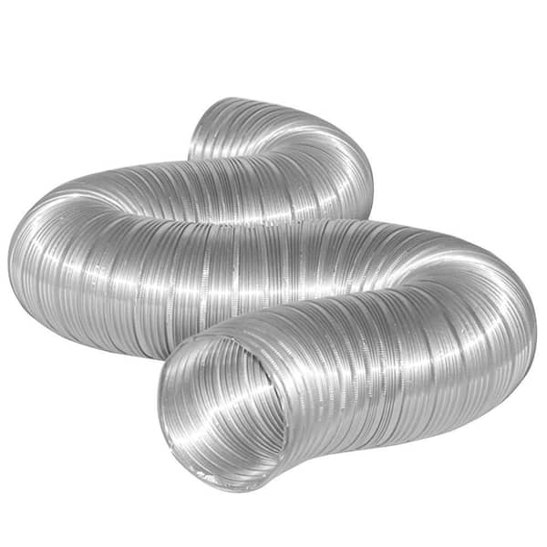
HomeDepot Link

21.97 USD

- Features a maximum heat resistance of 435⁰ F
- All aluminum products are fire resistant
- Flexible to allow for ease of installation
- Semi-rigid product holds its shape to help improve airflow
- 6 in. of diameter and stretches to 8 ft. L

Product specification
Internet # 203626515
Model # MFX68XHD
Store SKU # 606639
Dimensions
Product Depth (in.) | 27.08 in
Product Diameter (in.) | 6.0 in
Product Height (in.) | 6.4 in
Product Length (in.) | 96 in
Product Width (in.) | 6.4 in
Color | Silver
Insulated | No
Material | Aluminum
Pack Size | 4

6 in. Galvanized Steel Worm Gear Clamp
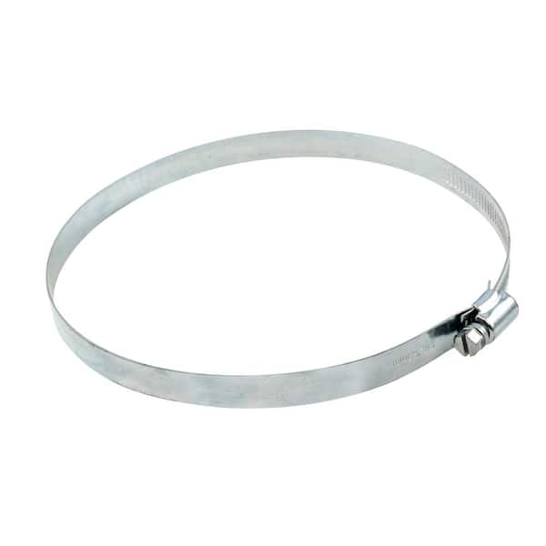
HomeDepot Link

4.47 USD

- Adjusts from 5-1/8 in. to 6-1/2 in.
- Can be used in all venting applications

Product specification
Internet # 203626509
Model # MC6HD
Store SKU # 599737
Dimensions
Product Depth (in.) | 0.08 in
Product Diameter (in.) | 6.0 in
Product Height (in.) | 6.12 in
Product Length (in.) | 0.25 in
Product Width (in.) | 6.12 in
Color | Silver
Insulated | No
Material | Galvanized Steel

6 in. Flexible Duct and Sheet Metal Connector Splice Collar
HomeDepot Link

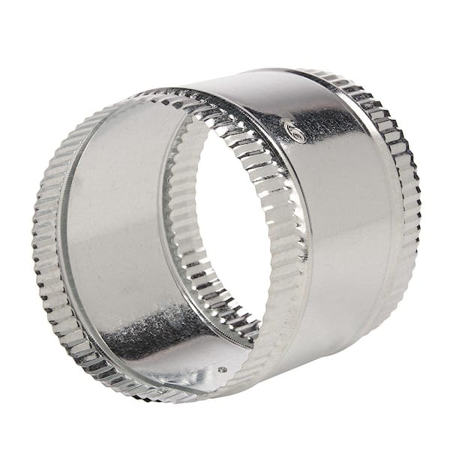
7.98 USD

- Used as a coupling between 2 sections of insulated flex duct
- Beaded for strength
- Easy installation with sheet metal screws
- Crimped on both sides for easy fit
- Always seal seams with code approved mastic or sealant (or duct tape)
- Features a maximum temperature rating of 390 degree F

Product specification
Internet # 100396940
Model # FC6
Store SKU # 812067
Dimensions
Product Depth (in.) | 6 in
Product Diameter (in.) | 6 in
Product Height (in.) | 5 in
Product Width (in.) | 6 in
Brand/Model Compatibility | Universal
HVAC application | All HVAC types
Material | Galvanized Steel
Product Weight (lb.) | 0.49 lb

6 in. 90 Deg. Round Adjustable Elbow
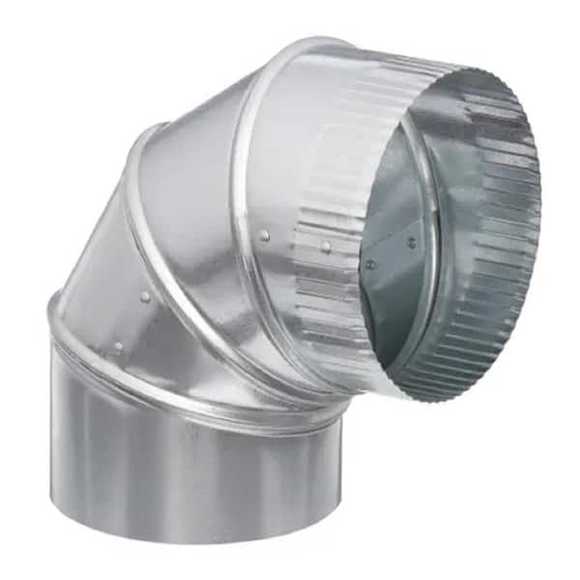
HomeDepot Link

8.68 USD

- Adjustable to any angle through 90°
- 30-Gauge galvanized steel
- Commonly used on HVAC applications
- Crimped end for easy installation
- Sturdy galvanized steel construction
- Simple to adjust

Product specification
Internet # 100062966
Model # B90E6
Store SKU # 148733
Dimensions
Product Depth (in.) | 6 in
Product Diameter (in.) | 6 in
Product Height (in.) | 9 in
Product Width (in.) | 6 in
Bend Degree | Adjustable
Brand/Model Compatibility | Universal
Gauge | 30
HVAC application | All HVAC types
Material | Galvanized Steel
Product Weight (lb.) | 0.875 lb

Swivel Threaded-Rod-Mount Loop Hanger
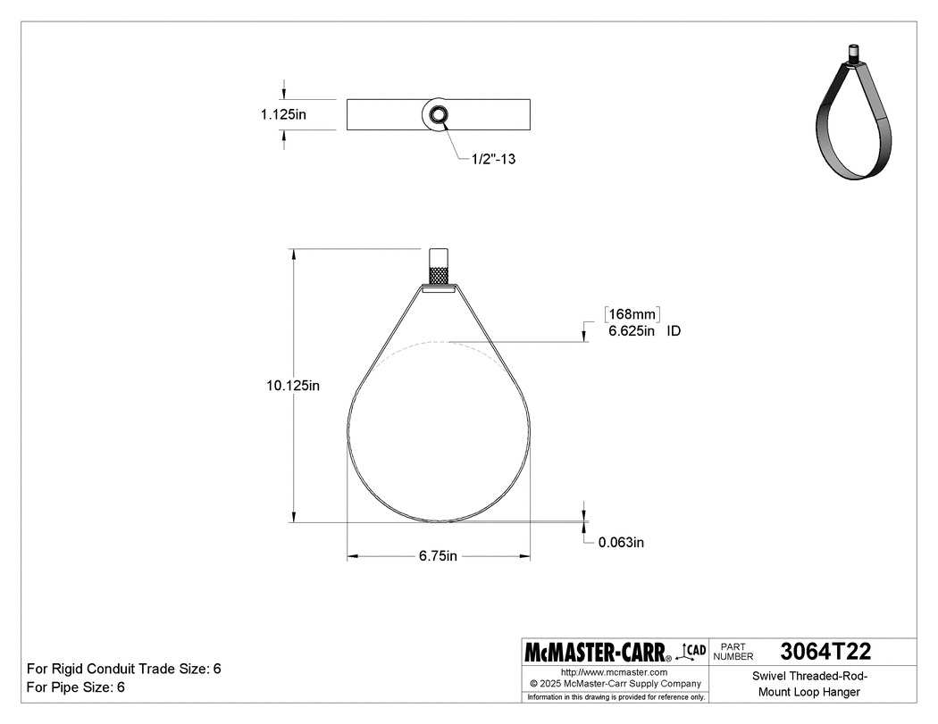
Zinc-Plated Steel, 6-5/8" ID
$9.40
3064T22
McMaster-Carr Link
Mount Type | Screw On
Material | Zinc-Plated Steel
ID | 3064T22
Inch | 6 5/8"
Metric | 168 mm
For Pipe Size | 6
For Rigid Conduit Trade Size | 6
For Thread Size | 1/2"-13
Capacity | 1,250 lbs.
Length | 6 13/16"
Width | 1 1/8"
Height | 10 1/8"
Thickness | 1/16"
Mounting Location | Ceiling, Threaded Rod
Features | Swivel Nut
※ If the duct hanger does not share parts with curtain rails, other economical alternatives can be considered.

Bullseye custom stand

Sheet Metal Supports
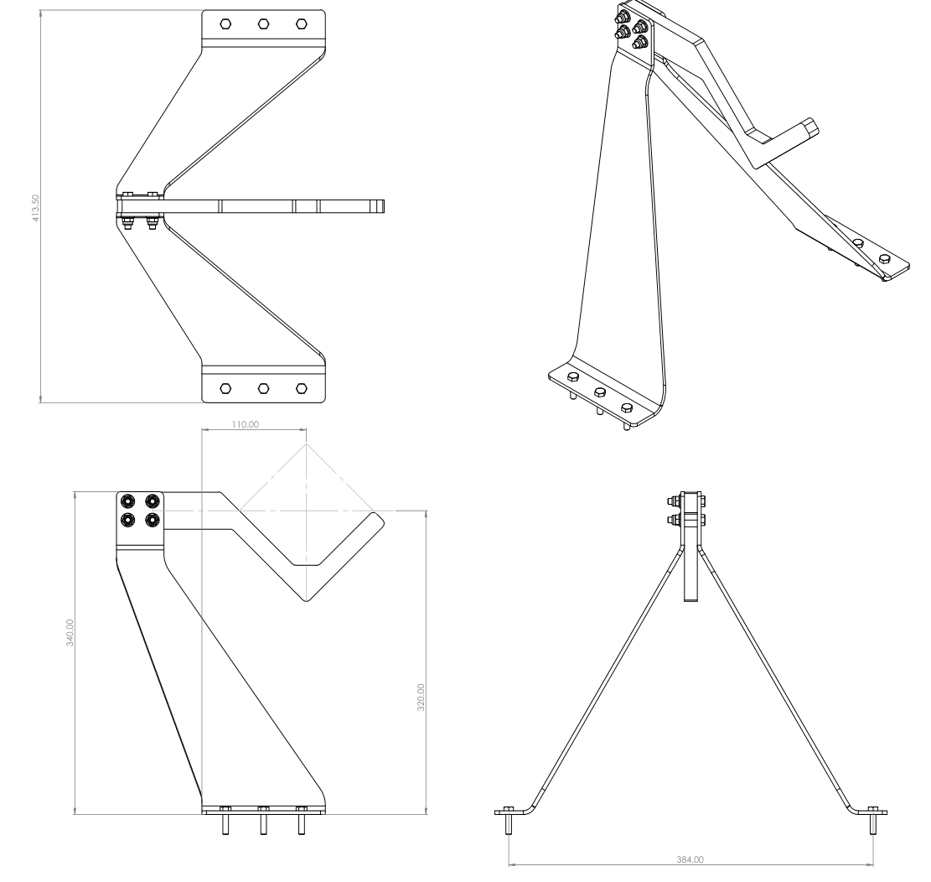
Installed Image
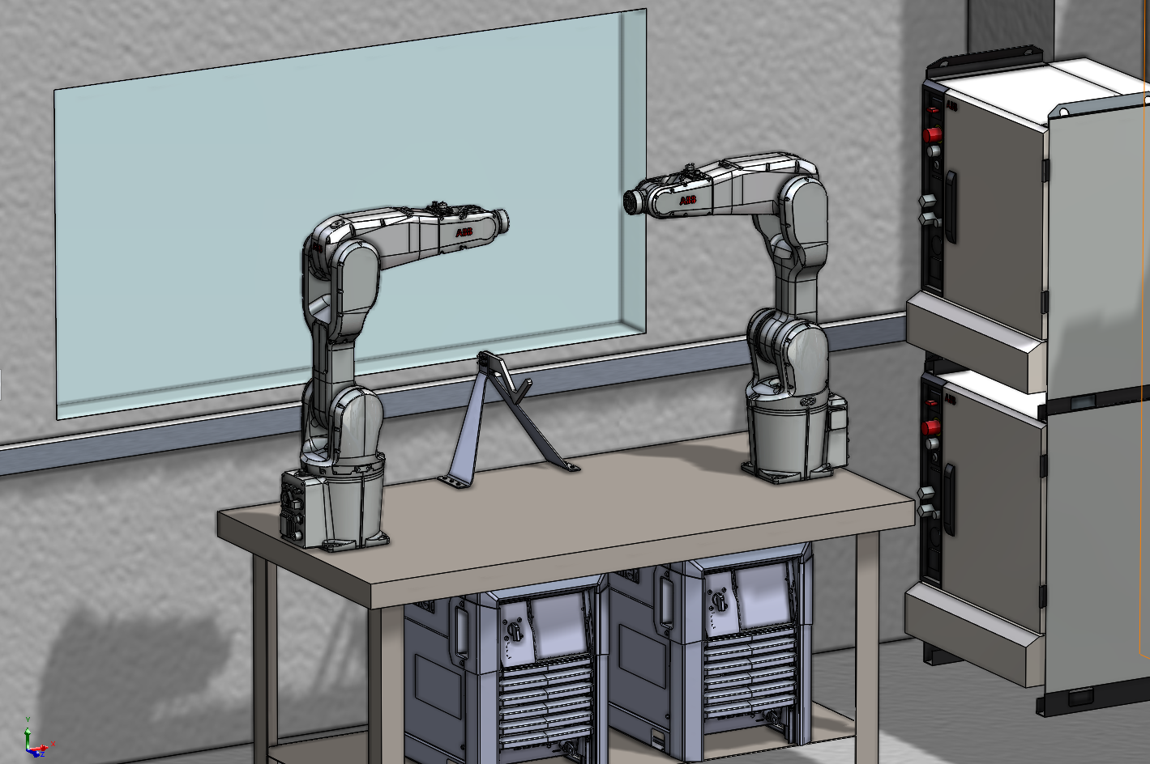

Supplier 1. SendCutSend (US)
https://app.sendcutsend.com

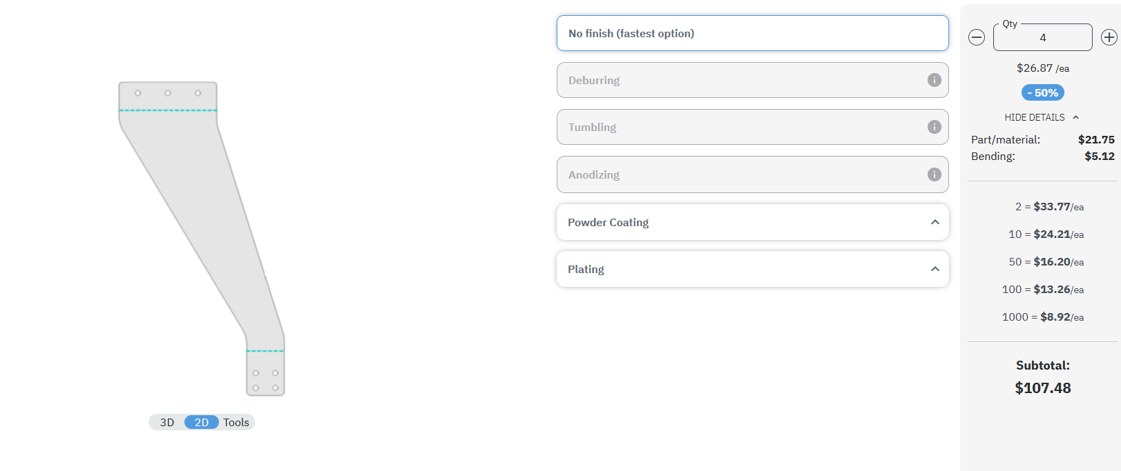
Price: 108 USD, 4 Parts
67.5 USD, 2 Parts.
Shipping: Included
Delivery Time: 4-5 Business Days

Supplier 2. JLCCNC (CN)
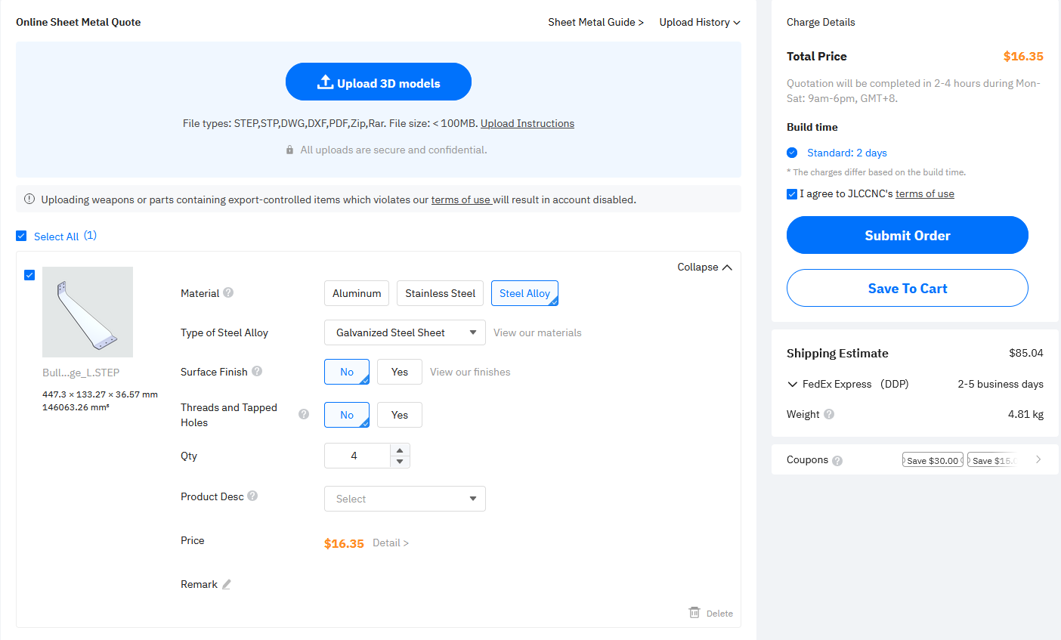
Price: 16.35 USD, 4 Parts
Shipping: 85.04 USD, 2-5 Business days
Total 740 CNY ≈ 105 USD

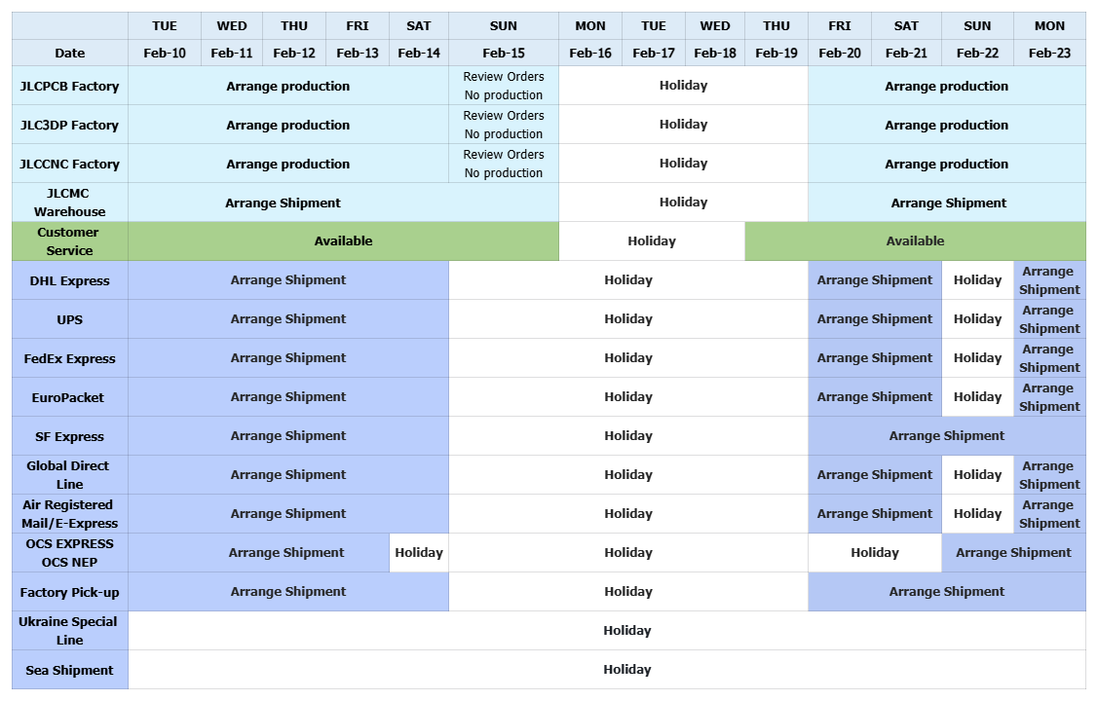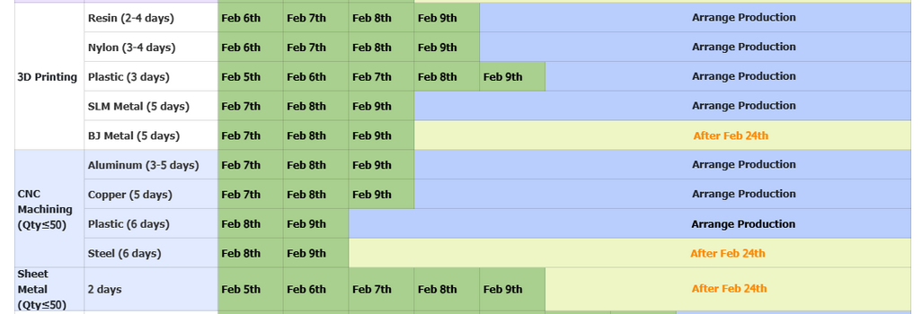
Order will be processed after Feb 24th.

